**Rasul 16.2.2016**

**Optimization results**

**Introduction**

In this chapter, results of the optimization problem which was described in details in the previous chapter will be discussed. As it is mentioned in previous chapter, a multi objective optimization of the switched reluctance machine in order to maximize both torque density and efficiency of the motor is aimed in this study. In order to investigate the optimum geometries and excitation patterns for maximization of torque density and efficiency separately and finally, when these parameters are combined in a single objective function, three separate optimizations will be carried out in this study. Furthermore, first two optimization results will be used to define the objective function of the final multi objective optimization. First, an optimization is done in order to determine the optimum geometry and excitation pattern of the SRM in which torque per motor active mass is maximized. In the second stage, the same optimization problem is solved for the maximum efficiency of the machine. Finally, a multi objective optimization is carried out to find the optimum geometry and excitation pattern in which a combined objective function which includes both torque density and efficiency, gains its maximum value.

**Torque density optimization results**

In this section, the objective is taken as torque per motor active mass, and the optimum geometry and excitation pattern in which torque density of the SRM is maximized will be determined. Four separate optimizations are done for four different Ns/Nr combinations (6/4, 8/6, 12/8 and 18/12). As it is mentioned in the previous chapter, number of populations in each generation is selected to be 200. Moreover, function tolerance and number of stall generations are selected to be 0.001 and 10 in determination of genetic algorithm stopping criteria. Upcoming section discuss the results of four separate genetic algorithm optimizations for four different stator and rotor pole combinations carried out using GA toolbox of MATLAB software.

1. Ns/Nr=6/4
2. Ns/Nr=8/6

For this pole combination, maximum and average values of torque density for each generation are shown in the following figure.

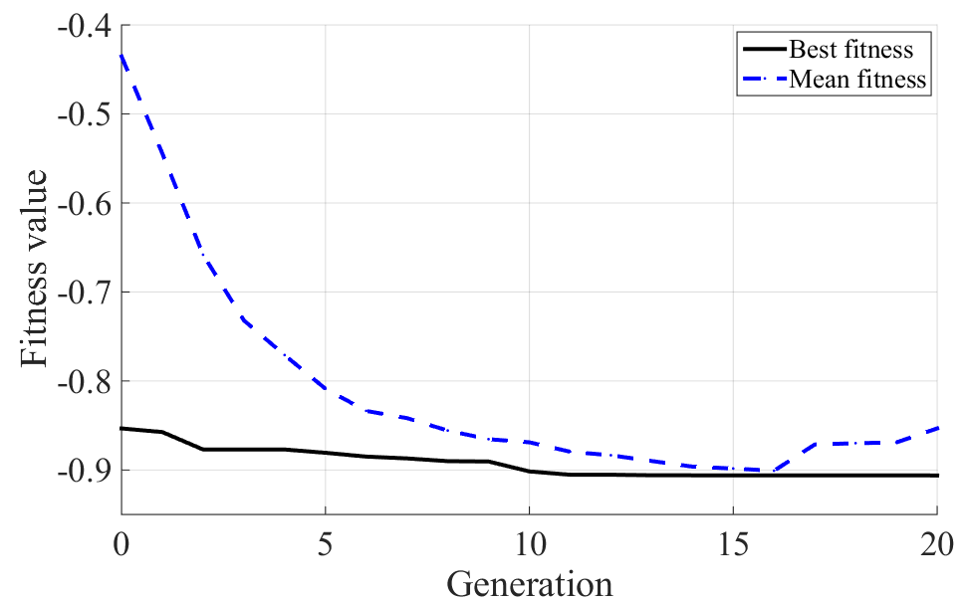

Distribution of torque density values for all the populations of the final generation can be seen in the following figure.

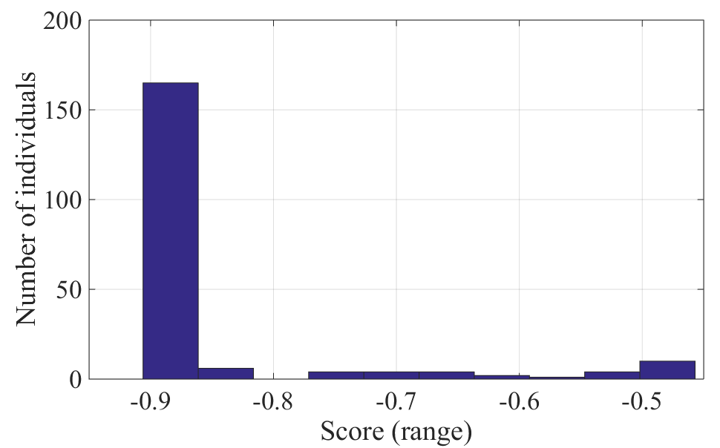

Average stator outer diameters in each generation is shown in the following figure. As it can be easily understood from the figure, stator outer diameter converges to Dos=269mm which is the maximum allowable diameter for this specific HEV application. This constraint is entered into optimization problem as a penalty function which was discussed earlier in the previous chapter.

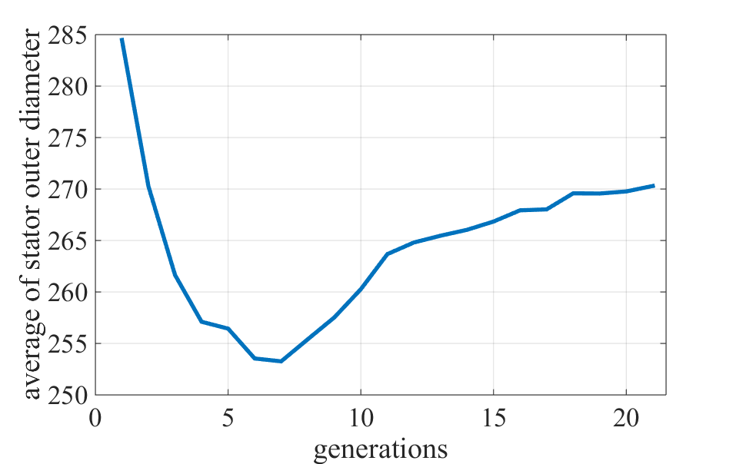

The corresponding penalty function average value in each generation is plotted against generations in the following figure.

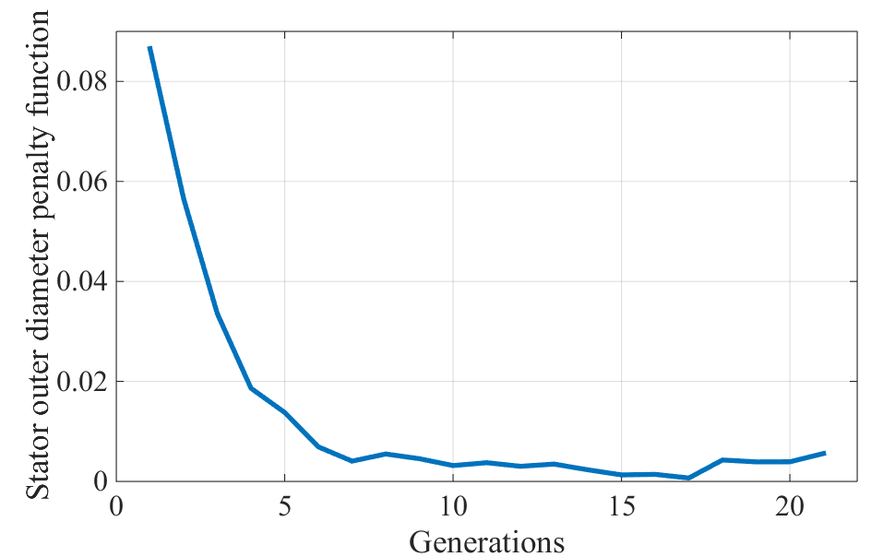

Variations in average values of turns per pole, output torque, SRM mass and torque per active mass of the machine which is the objective function of the optimization problem are plotted in four following figures.

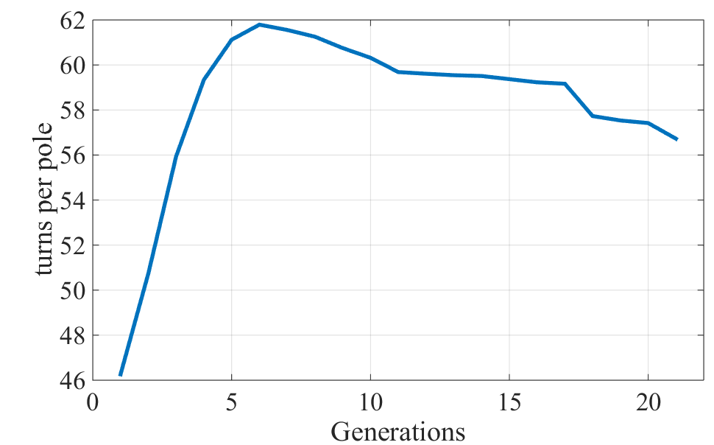

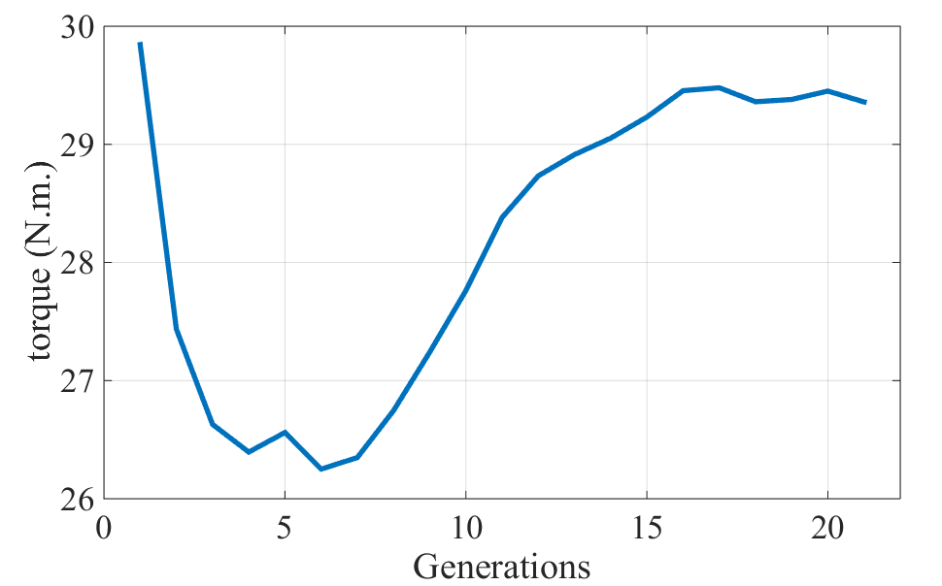

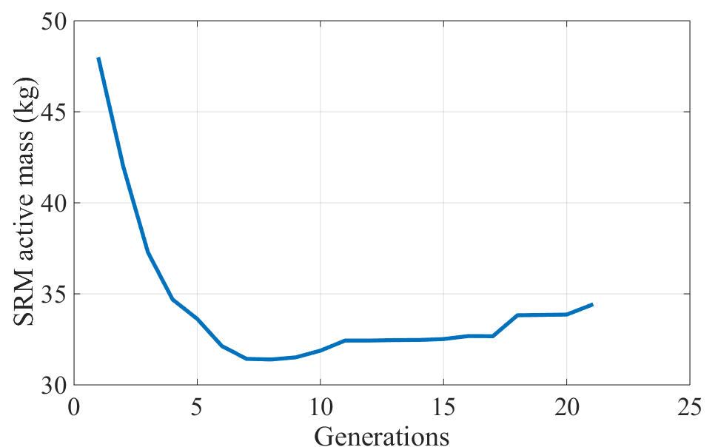

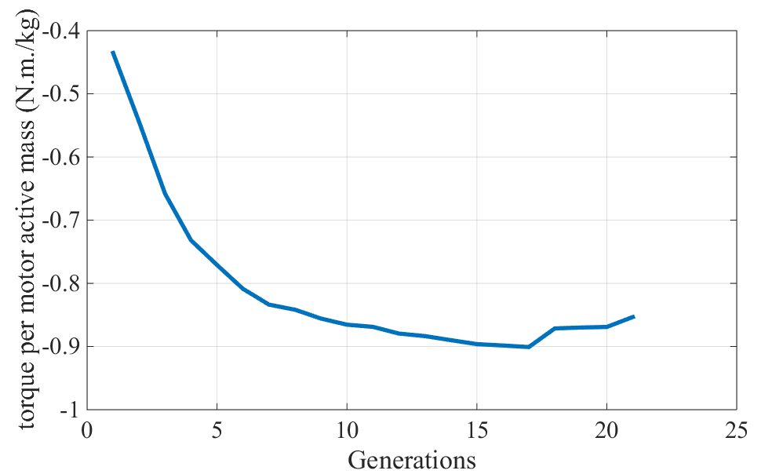

The optimum point geometric dimensions and excitation pattern which are the independent variables of the optimization problem and torque density of the optimum point are summarized in the following table.

|  |  |  |  |  |  |  |
| --- | --- | --- | --- | --- | --- | --- |
| λ/g | ts/ λ | tr/ λ | Dor (mm) | Excitation period (electrical degree) | Firing angle (electrical degree) | Torque per motor active mass (N.m./kg) |
| 147.3 | 0.305 | 0.305 | 172.19 | 98.54 | 49.02 | 0.906 |

Using the independent variables, the SRM can be simply designed using the method described in the previous chapter. Following table contains geometric dimensions and winding configuration of the optimum switched reluctance motor for this pole combination.

|  |  |  |  |  |  |  |  |  |  |
| --- | --- | --- | --- | --- | --- | --- | --- | --- | --- |
|  |  |  |  |  |  |  |  |  |  |
|  |  |  |  |  |  |  |  |  |  |

Static and dynamic performance characteristics of the optimized machine can then be simply calculated. Analytical calculation results can be seen in the following table.

|  |  |  |  |  |  |  |  |  |  |
| --- | --- | --- | --- | --- | --- | --- | --- | --- | --- |
|  |  |  |  |  |  |  |  |  |  |
|  |  |  |  |  |  |  |  |  |  |

1. Ns/Nr=12/8
2. Ns/Nr=18/12

Best objective function value (the maximum torque density) and average value of this function for all the populations in each generation are shown in the following figure.

Fig. represents the distribution of the objective function quantity for all the individuals in the final generation.

Optimization results including input variables and torque density value for the optimum point for this specific tooth combination are summarized in the following table.

|  |  |  |  |  |  |  |
| --- | --- | --- | --- | --- | --- | --- |
| λ/g | ts/ λ | tr/ λ | Dor (mm) | Excitation period (electrical degree) | Firing angle (electrical degree) | Torque per motor active mass (N.m./kg) |
| Value |  |  |  |  |  |  |

Geometric dimensions and winding configuration of the optimized machine which calculated using the method described in previous chapters can be seen below.

|  |  |  |  |  |  |  |  |  |  |
| --- | --- | --- | --- | --- | --- | --- | --- | --- | --- |
|  |  |  |  |  |  |  |  |  |  |
|  |  |  |  |  |  |  |  |  |  |

Finally, results of static and dynamic calculations of the SRM are summarized in table (). Note that these results are obtained using the analytical method discussed in previous chapters.

|  |  |  |  |  |  |  |  |  |  |
| --- | --- | --- | --- | --- | --- | --- | --- | --- | --- |
|  |  |  |  |  |  |  |  |  |  |
|  |  |  |  |  |  |  |  |  |  |